crp2019: Hotel information

Block booking has been arranged at the following hotels for 3 nights, between September 12 and 15 (participants must reserve and pay for their accommodation by themselves):

Mercure Budapest Korona****
Address: H-1053 Budapest, Kecskeméti u. 14.

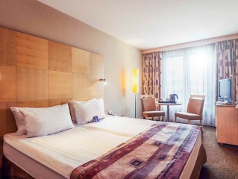

Standard room (single): 139 EUR/room/night
Standard room (double): 149 EUR/room/night
For reservation, please make a double-click the booking form icon:

More information about the hotel: https://www.accorhotels.com/gb/hotel-1765-mercure-budapest-korona-hotel/index.shtml
(final hotel room reservation and payment by participants)

Danubius Hotel Gellért****
Address: H-1114 Budapest, Szent Gellért tér 2.

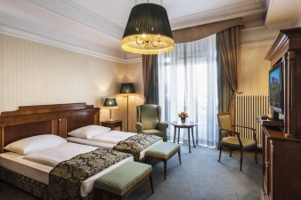

Standard room: from 148 EUR/room/night
Superior room: from 165 EUR/room/night
15% discount is offered for CRP Conference participants from daily rates

For reservation, please make a double-click on the booking form icon:
More information about the hotel: https://www.danubiushotels.com/en/our-hotels-budapest/danubius-hotel-gellert

InterContinental Budapest*****
Address: H-1051 Budapest, Apáczai Csere János u. 10.

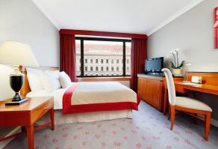

Standard room (single): 219 EUR/room/night
Standard room (double): 239 EUR/room/night
For reservation, please use the following link: https://book.passkey.com/go/CRPAnnualConference2019
More information about the hotel: http://www.budapest.intercontinental.com

Other hotels near BME campus (no block booking or special price arranged!):

Ibis Styles Budapest City***
Address: H-1095 Budapest, Soroksári út 12.
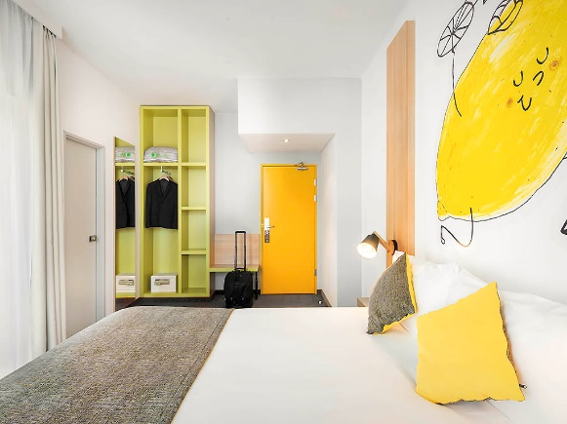
More information about the hotel:
http://www.ibis.com/gb/hotel-2025-ibis-styles-budapest-city/index.shtml

Hotel Kálvin Ház***
Address: H-1093 Budapest, Gönczi Pál utca 6.
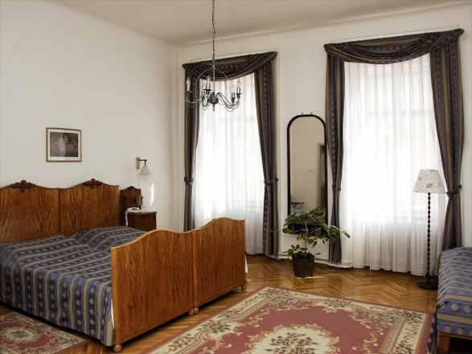
More information about the hotel:
http://www.kalvinhouse.hu/?lang=eng

Danubius Hotel Flamenco****
Address: H-1113 Budapest, Tas vezér utca 3-7.
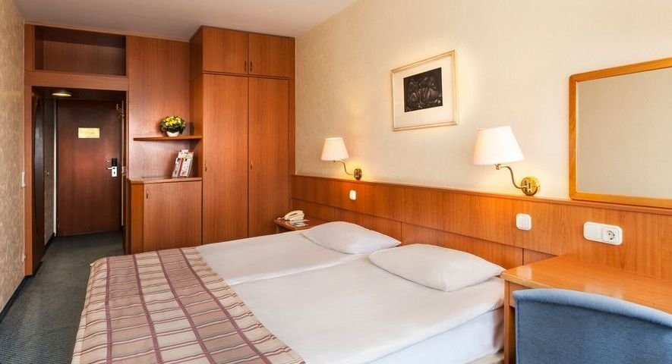
More information about the hotel: https://www.danubiushotels.com/en/our-hotels-budapest/danubius-hotel-flamenco

Lánchíd 19 Design Hotel****
Address: H-1013 Budapest, Lánchíd utca 19.
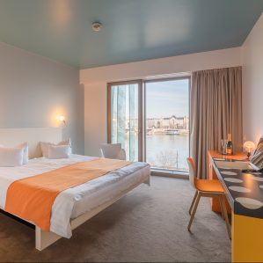
More information about the hotel: https://www.lanchid19hotel.com/

